**Ascendion Timesheet Confirmation**

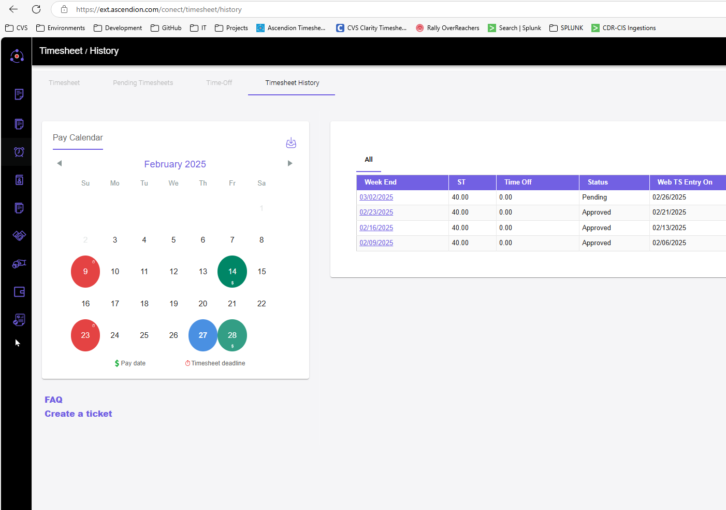**Preston Brown**

**General Git Commands**

git restore .

git checkout .

git commit -m "PRNAME"

git push origin

git pull origin dev

git status

**General Powershell (**Run cmd in elevated | type powershell**)**

Rename file and append extension

gci -file | ren -N {$_.Name + '.txt'}

Append string to file name

for %a in (*.hl7) do ren '%a' 'PCCMAVIL_INBOUND_%a'

gci -file | ren -N {'PCCMAVIL_INBOUND_' + $_.Name}

gci -file | ren -N {'PCCMAVIL_INBOUND_' + $_.Name + '.hl7'}